Founder 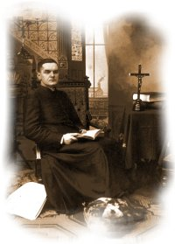 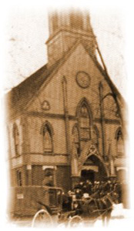 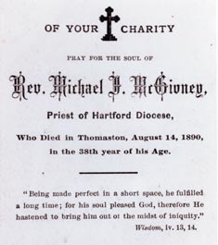
People who knew Father McGivney in this period were impressed by his energy and intensity. Father Gordian Daley later recalled, "I saw him but once, and yet I remember this pale, beautiful face as if I saw it only yesterday. It was a 'priest's face' and that explains everything. It was a face of wonderful repose. There was nothing harsh in that countenance although there was everything that was strong."
William Geary, one of the Order’s charter members, said that at the first council meeting in 1882, Father McGivney was "Acclaimed as founder by 24 men with hearts full of joy and thanksgiving; recognizing that without his optimism, his will to succeed, his counsel and advice they would have failed."
Father McGivney had originally suggested Sons of Columbus as a name for the Order. This would bind Catholicism and Americanism together through the faith and bold vision of the New World’s discoverer. However, the word “knights” replaced “sons” because key members of the organizing group who were Irish-born Civil War veterans felt it would help to apply a noble ritual in support of the emerging cause of Catholic civil liberty.
The first public references to the Order came on February 8, 1882. Both the New Haven Morning Journal and the New Haven Courier reported that the Knights of Columbus had held an initial meeting the night before.
On March 29, the Connecticut legislature granted a charter to the Knights of Columbus, formally establishing it as a legal corporation. The Order’s principles in 1882 were "unity" and "charity." The concepts of "fraternity" and "patriotism" were added later. Each of these ideals played a major role in ceremonials from the beginning. The Columbus-linked themes, says historian Christopher J. Kauffman, "reverberated with pride in the American promise of liberty, equality and opportunity."
In April 1882, Father McGivney, with the permission of Bishop McMahon, wrote
an informative letter about the Knights of Columbus to all the pastors of the Diocese of Hartford. In the letter, Father McGivney stated that the Order’s primary objective was to dissuade Catholics from joining secret societies by providing them with Catholic societies that had better advantages at times of death or sickness. He urged each pastor to exert influence "in the formation of a council in your parish." Father McGivney personally installed the first officers of San Salvador Council 1 in New Haven, in May 1882.
By May 1883, Council 2 had been instituted in Meriden, Connecticut and Bishop McMahon, so impressed with the organization, became a member of Council 11 in 1884, and served as its council chaplain. By the end of 1885, there were 31 councils in Connecticut.
Father McGivney’s dedication to the Order was evidenced in trips he made to all parts of Connecticut and in handwritten correspondence—little of which survives—about K of C business. Despite all this, he remained an energetic curate at St. Mary’s and had constant concern for every parishioner’s problems.
In November 1884, he was named pastor of St. Thomas Church in Thomaston, Conn., a factory town 10 miles from his hometown. Heavily in debt, the parish served working-class parishioners with few resources beyond their faith. With prayerful acceptance, Father McGivney put his seven years at St. Mary’s behind him and traveled to Thomaston.
His New Haven parishioners, in a testimonial resolution which was elaborately superimposed on the drawing of a chalice and host, declared that despite burdens and afflictions, his courtesy, his kindness and the purity of his life had, "Secured the love and confidence of the people of St. Mary’s, which will follow him in every future field of labor."
In six subsequent years at St. Thomas, Father McGivney wrestled with the church's debt and built the same close ties of devotion and charitable concern that he had developed in New Haven. He continued, as well, to serve as supreme chaplain of the Knights of Columbus, personally involved in helping the Order to extend its membership into Rhode Island. Later, from 1901 to 1939, his younger brothers, Msgrs. Patrick and John J. McGivney, served the Order as supreme chaplains.
Never robust in health, Father McGivney was suddenly stricken with a serious case of pneumonia in January 1890. It hung on. Various treatments for consumptive illness were tried, but his decline continued. The young priest lost physical strength just as the Order he founded was moving toward new vitality, and died on August 14, two days past his 38th birthday.
Later that August, one of the largest funerals in the history of Waterbury, Conn., took place. The bishop of Hartford and more than 70 of Connecticut’s Catholic priests were joined by many civic leaders and throngs of other attendees. It was reported that mourners rented every available carriage within miles for the great procession.
Father McGivney’s funeral was an indication of the love and respect the people felt for this hard-working, holy parish priest. It also reflected the deep personal appeal that immigrant Catholics immediately found in the Knights of Columbus.
Delegations were present from almost every one of the 57 Knights of Columbus councils that had been chartered in the Order’s first eight years.
The Life and Legacy of Father McGivney is a production that should be seen by every Knight.

